Academic Literature 4
The Canterbury Tales
Geoffrey Chaucer

Name:________________________________________ Period: ________

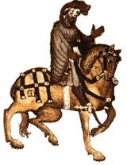
Knight’s Profile:_________________________________________________________________________________________________________________________________________________________________________________________________________________________________________________________________________________________________________________________________________________________________________________________________________________________________________________________________________________________________________________________________________________________________________________________________________________________________________________________.

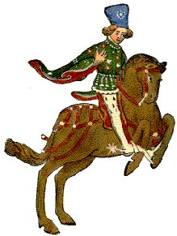
Squire Profile: ______________________________________________________________________________________________________________________________________________________________________________________________________________________________________________________________________________________________________________________________________________________________________________________________________________________________________________________________________________________________________________________________________________________.

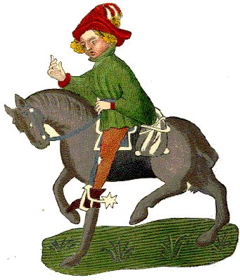
Yeoman Profile: ______________________________________________________________________________________________________________________________________________________________________________________________________________________________________________________________________________________________________________________________________________________________________________________________________________________________________________________________________________________________________________________________________________________.

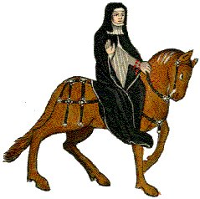
Prioress’ (Nun)(Secretary nun & Three Priests))Profile:________________________________________________________________________________________________________________________________________________________________________________________________________________________________________________________________________________________________________________________________________________________________________________________________________________________________________________________________________________________________________________________________________________________________________________________________________________________________________________.

Monk Profile:_________________________________________________________________________________________________________________________________________________________________________________________________________________________________________________________________________________________________________________________________________________________________________________________________________________________________________________________________________________________________________________________________________________________________________________________________________________________________________________________.

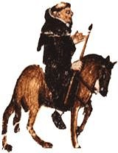
Friar Profile: ______________________________________________________________________________________________________________________________________________________________________________________________________________________________________________________________________________________________________________________________________________________________________________________________________________________________________________________________________________________________________________________________________________________.

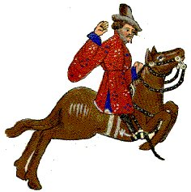
Merchant Profile: ______________________________________________________________________________________________________________________________________________________________________________________________________________________________________________________________________________________________________________________________________________________________________________________________________________________________________________________________________________________________________________________________________________________.

Oxford Cleric Profile: ___________________________________________________________________________________________________________________________________________________________________________________________________________________________________________________________________________________________________________________________________________________________________________________________________________________________________________.

Serjeant at the Law Profile:
___________________________________________________________________________________________________________________________________________________________________________________________________________________________________________________________________________________________________________________________________________________________________________________________________________________________________________.

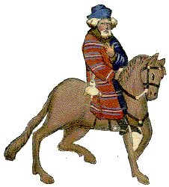
Franklin Profile:
______________________________________________________________________________________________________________________________________________________________________________________________________________________________________________________________________________________________________________________________________________________________________________________________________________________________________________________________________________________________________________________________________________________.

Haberdasher, Dyer, Carpenter, Weaver, and Carpet-maker Profile: ___________________________________________________________________________________________________________________________________________________________________________________________________________________________________________________________________________________________________________________________________________________________________________________________________________________________________________.

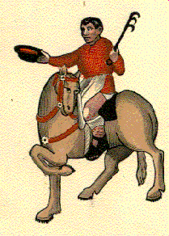
Cook Profile: ________________________________________________________________________________________________________________________________________________________________________________________________________________________________________________________________________________________________________________________________.

Skipper Profile: ___________________________________________________________________________________________________________________________________________________________________________________________________________________________________________________________________________________________________________________________________________________________________________________________________________________________________________.

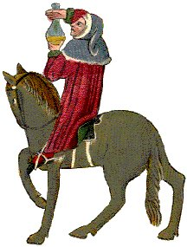
Physician Profile: ___________________________________________________________________________________________________________________________________________________________________________________________________________________________________________________________________________________________________________________________________________________________________________________________________________________________________________.

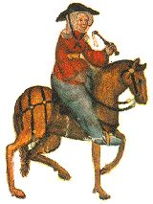
Wife of Bath Profile: ______________________________________________________________________________________________________________________________________________________________________________________________________________________________________________________________________________________________________________________________________________________________________________________________________________________________________________________________________________________________________________________________________________________.

Parson Profile: ___________________________________________________________________________________________________________________________________________________________________________________________________________________________________________________________________________________________________________________________________________________________________________________________________________________________________________.

Plowman Profile: ___________________________________________________________________________________________________________________________________________________________________________________________________________________________________________________________________________________________________________________________________________________________________________________________________________________________________________.

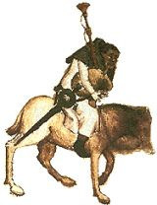
Miller Profile: ______________________________________________________________________________________________________________________________________________________________________________________________________________________________________________________________________________________________________________________________________________________________________________________________________________________________________________________________________________________________________________________________________________________.

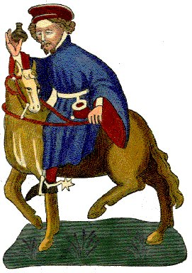
Manciple Tale: ___________________________________________________________________________________________________________________________________________________________________________________________________________________________________________________________________________________________________________________________________________________________________________________________________________________________________________.

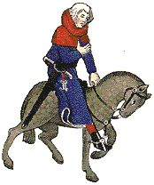
Reeve Profile: ___________________________________________________________________________________________________________________________________________________________________________________________________________________________________________________________________________________________________________________________________________________________________________________________________________________________________________.

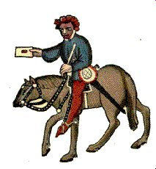
Summoner Profile: ______________________________________________________________________________________________________________________________________________________________________________________________________________________________________________________________________________________________________________________________________________________________________________________________________________________________________________________________________________________________________________________________________________________.

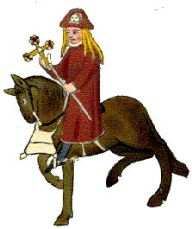
Pardoner Profile: ______________________________________________________________________________________________________________________________________________________________________________________________________________________________________________________________________________________________________________________________________________________________________________________________________________________________________________________________________________________________________________________________________________________.

The Tabard: ______________________________________________________________________________________________________________________________________________________________________________________________________________________________________________________________________________________________________________________________________________________________________________________________________________________________________________________________________________________________________________________________________________________.

The Host: ______________________________________________________________________________________________________________________________________________________________________________________________________________________________________________________________________________________________________________________________________________________________________________________________________________________________________________________________________________________________________________________________________________________.

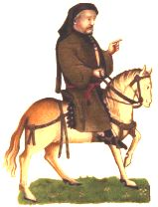
Chaucer Profile: ______________________________________________________________________________________________________________________________________________________________________________________________________________________________________________________________________________________________________________________________________________________________________________________________________________________________________________________________________________________________________________________________________________________.

